**ERROR HANDLING(22.07.24)**

**1.**

public class ExceptionEx1 {

public static void main(String args[]) {

int[] nums = {3, 2, 6, 1};

exp(nums);

}

public static void exp(int[] a) {

int total = 0;

try {

for (int i = 0; i < a.length; i++) {

int index = a[i];

total += a[index];

}

System.out.println(total);

} catch (ArrayIndexOutOfBoundsException e) {

System.err.println("Array index out of bounds exception occurred!");

} catch (NullPointerException e) {

System.err.println("Null pointer exception occurred!");

}

}

}

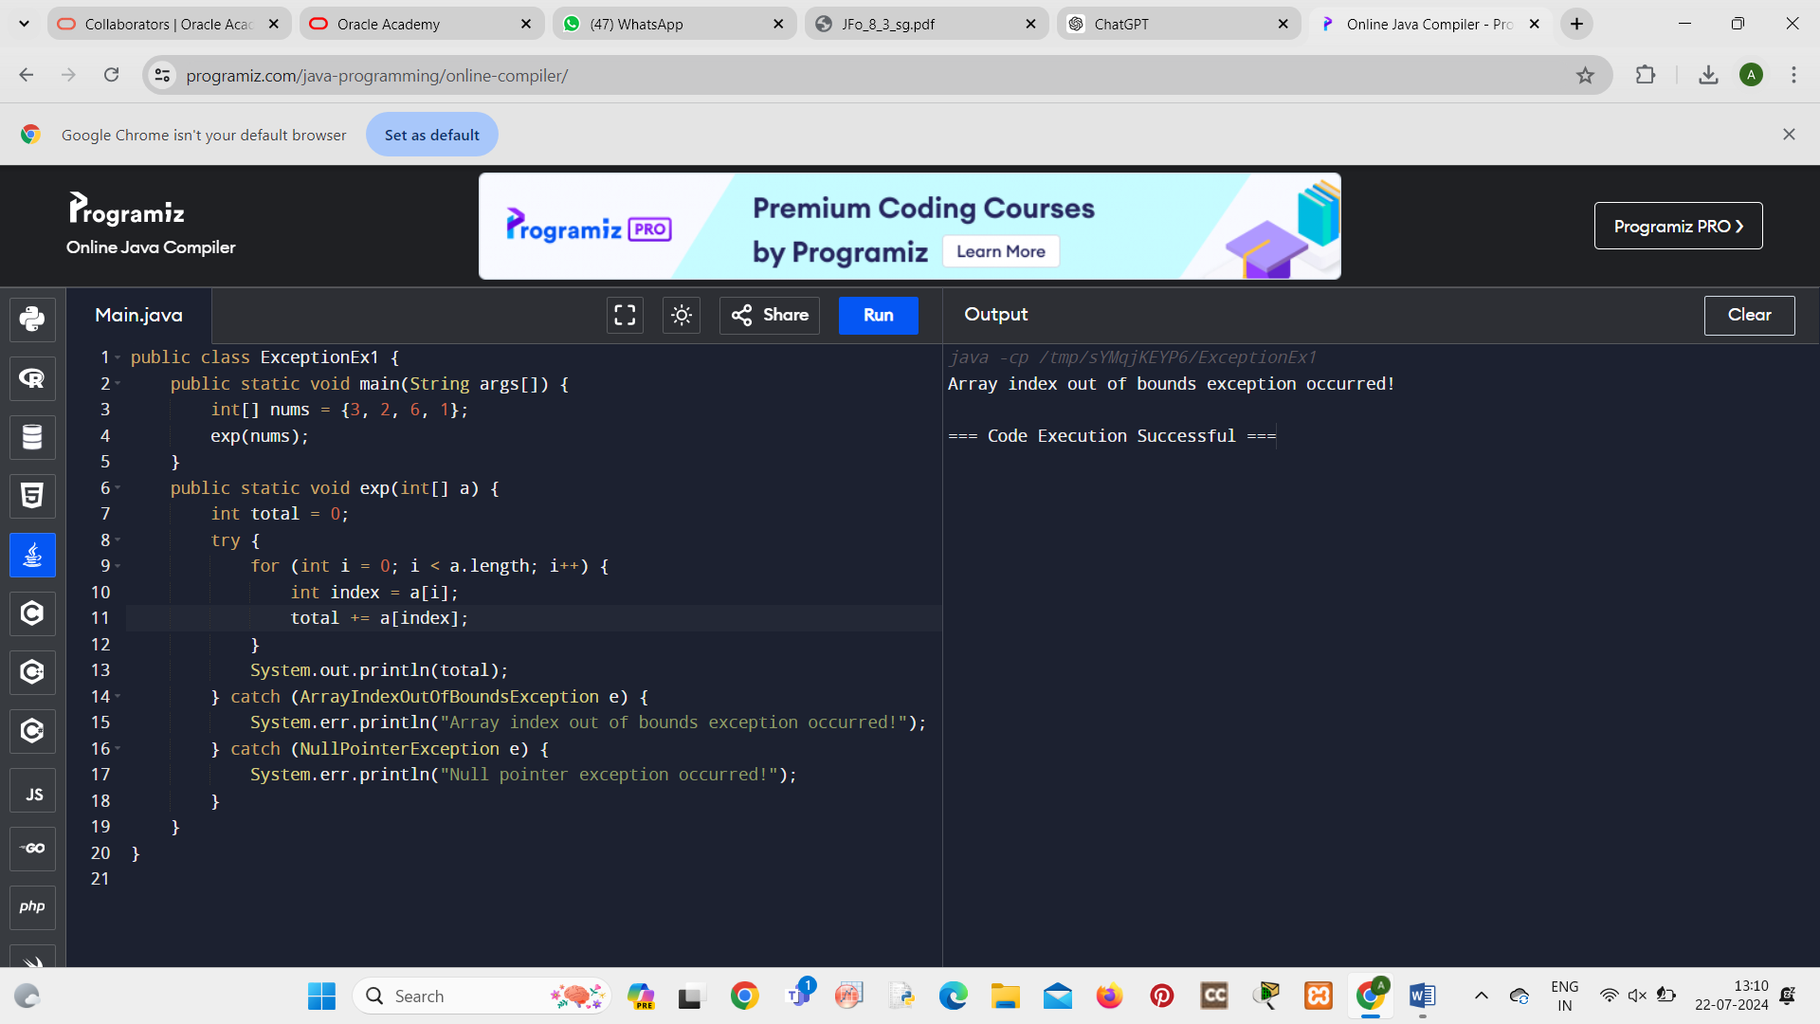

2.

public class Calculator {

public int add(int x, int y) {

return x + y;

}

public double divide(int x, int y) {

double result = 0;

try {

result = x / y;

} catch (ArithmeticException e) {

System.err.println("Arithmetic Exception: Division by zero!");

}

return result;

}

public static void main(String[] args) {

Calculator calc = new Calculator();

System.out.println(calc.add(5, 3));

System.out.println(calc.divide(10, 0));

}

}

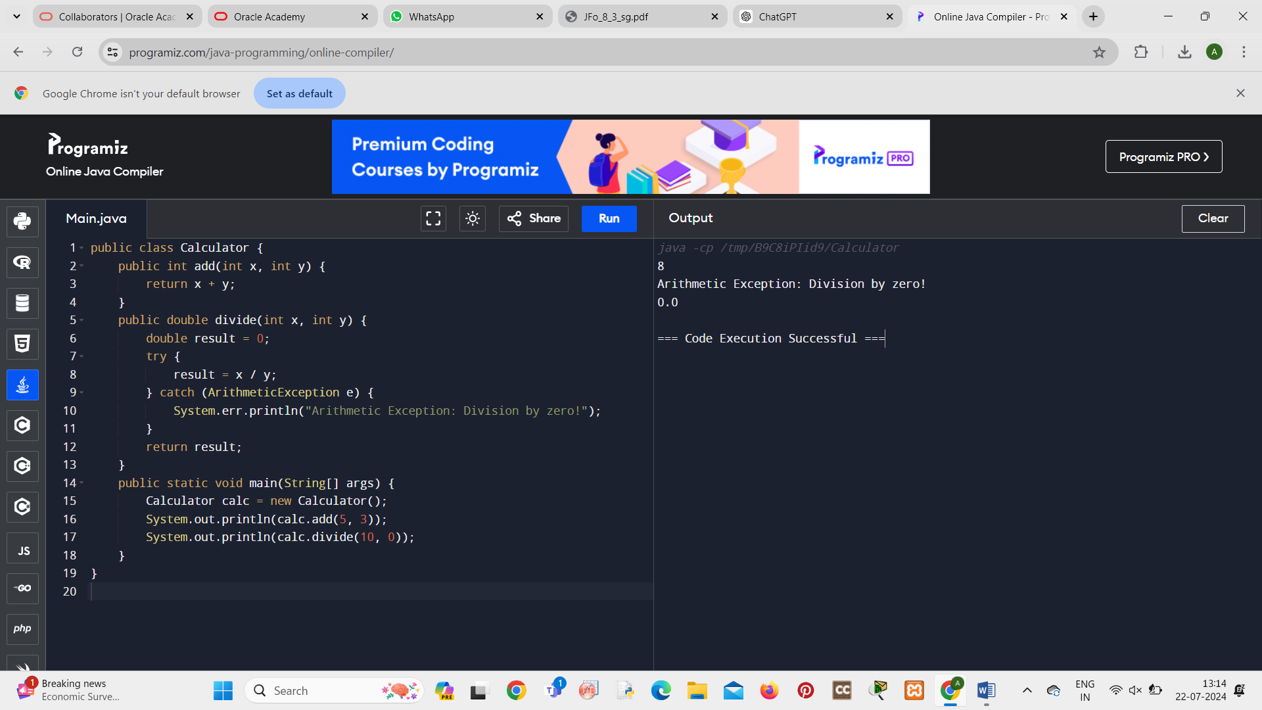

3.

